Website: https://www.websequencediagrams.com/

Flow of the document goes:
Code
Image

Code
Image

Register

@startuml
title Register (Email or Phone): Authentication

actor User
participant ":System" as System
participant "AuthService" as AuthService
participant "FirebaseAuthentication" as FirebaseAuth
participant "FirebaseRepository" as Repo

User -> System: Submit registration details\n(email + password | phone + password)

alt Email registration
System -> AuthService: registerEmail (email, password)
AuthService -> FirebaseAuth: createUser (email, password)
FirebaseAuth --> AuthService: userId
else Phone registration
System -> AuthService: registerPhone (phoneNum, password)
AuthService -> FirebaseAuth: createUser (phoneNum, password)
FirebaseAuth --> AuthService: userId
end

AuthService -> AuthService: create User profile\n(userId, role = "CUSTOMER")
AuthService -> Repo: saveUser (user)
Repo --> AuthService: success

AuthService --> System: User
System --> User: Registration successful

@enduml

Sign In
@startuml
title Sign In (Email or Phone Number)

actor User
participant ":System" as System
participant "AuthService" as AuthService
participant "FirebaseAuthentication" as FirebaseAuth

User -> System: Submit login details\n(email + password OR phoneNum + password)

alt Email sign-in
System -> AuthService: signInEmail (email, password)
AuthService -> FirebaseAuth: signIn (email, password)
FirebaseAuth --> AuthService: userId
else Phone sign-in
System -> AuthService: signInPhone (phoneNum, password)
AuthService -> FirebaseAuth: signIn (phoneNum, password)
FirebaseAuth --> AuthService: userId
end

AuthService --> System: User
System --> User: Login successful

@enduml

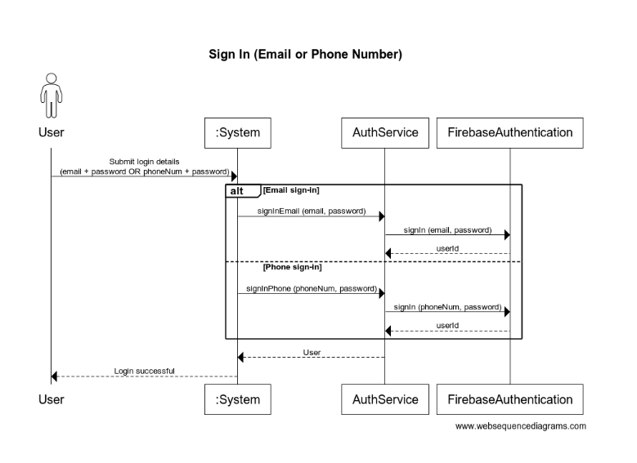

View Events
@startuml
title View Events

actor User
participant ":System" as System
participant "EventService" as EventService
participant "FirebaseRepository" as Repo

== View Events ==

User -> System: Open events list
System -> EventService: listEvents ()
EventService -> Repo: listEvents ()
Repo --> EventService: List<Event>
EventService --> System: List<Event>
System --> User: Display events list

@enduml

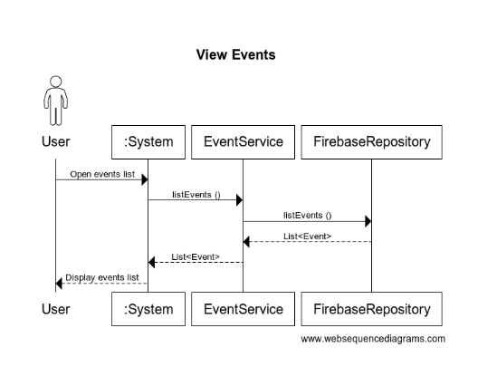

Search Events
@startuml
title Search Events

actor User
participant ":System" as System
participant "EventService" as EventService
participant "FirebaseRepository" as Repo

User -> System: Enter search keyword
System -> EventService: searchEvents(filters={keyword})

EventService -> Repo: getFilteredEvents(filters)
Repo --> EventService: List<Event>

EventService --> System: List<Event>
System --> User: Display search results

@enduml

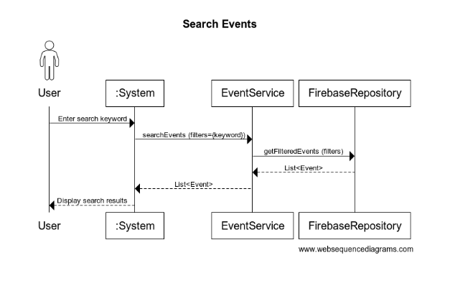

Filter Events

@startuml
title Filter Events

actor User
participant ":System" as System
participant "EventService" as EventService
participant "FirebaseRepository" as Repo

User -> System: Select filters\n(location/date/category)
System -> EventService: searchEvents (filters)

EventService -> Repo: getFilteredEvents (filters)
Repo --> EventService: List<Event>

EventService --> System: List<Event>
System --> User: Display filtered events

@enduml

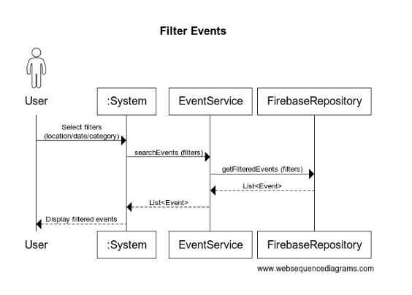
Reserve Tickets
@startuml
title Reserve Tickets

actor User
participant ":System" as System
participant "ReservationService" as ResService
participant "FirebaseRepository" as Repo
participant "NotifService" as Notif

User -> System: Reserve tickets\n(eventId, quantity)
System -> ResService: reserveTickets (userId, eventId, quantity)

' Atomic seat update
ResService -> Repo: transaction(eventId, quantity)

alt Seats available (transaction success)
Repo --> ResService: true

ResService -> Repo: createReservation (reservation)
Repo --> ResService: reservationId

ResService -> Notif: sendConfirmationMsg (recipient, message)
Notif --> ResService: sent

ResService --> System: Reservation
System --> User: Show confirmation\n(reservationId)

else Not enough seats (transaction fail)
Repo --> ResService: false
ResService --> System: error "Not enough seats"
System --> User: Show error message
end

@enduml

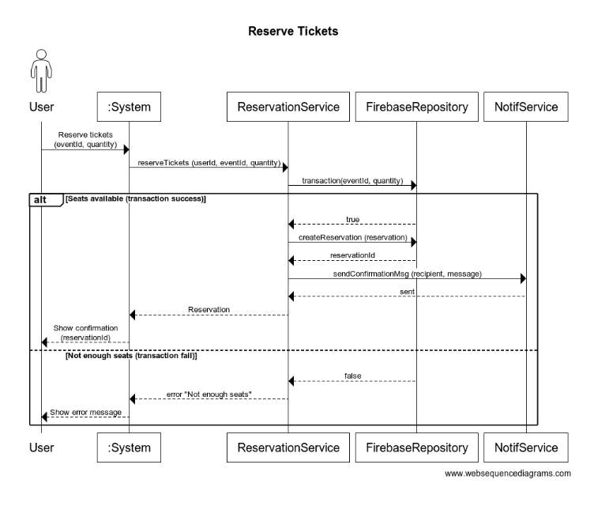

View Reservations
@startuml
title View Reservations

actor User
participant ":System" as System
participant "ReservationService" as ResService
participant "FirebaseRepository" as Repo

User -> System: View my reservations
System -> ResService: listReservations (userId)
ResService -> Repo: getReservationsByUser (userId)
Repo --> ResService: List<Reservation>
ResService --> System: List<Reservation>
System --> User: Display reservations

@enduml

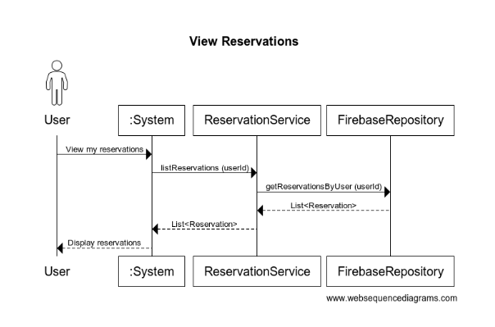

Cancel Reservation
@startuml
title Cancel Reservation

actor User
participant ":System" as System
participant "ReservationService" as ResService
participant "FirebaseRepository" as Repo
participant "NotifService" as Notif

User -> System: Cancel reservation\n(reservationId)
System -> ResService: cancelReservation (userId, reservationId)

ResService -> Repo: getReservation (reservationId)
Repo --> ResService: Reservation

alt Reservation valid AND not cancelled
ResService -> Repo: transaction (eventId, -quantity)
Repo --> ResService: true

ResService -> Repo: updateReservation (reservation)\n(status="CANCELLED")
Repo --> ResService: success

ResService -> Notif: sendCancellationMsg (recipient, message)
Notif --> ResService: sent

ResService --> System: success
System --> User: Cancellation confirmed
else Invalid reservation
ResService --> System: error "Invalid reservation"
System --> User: Show error message
end

@enduml

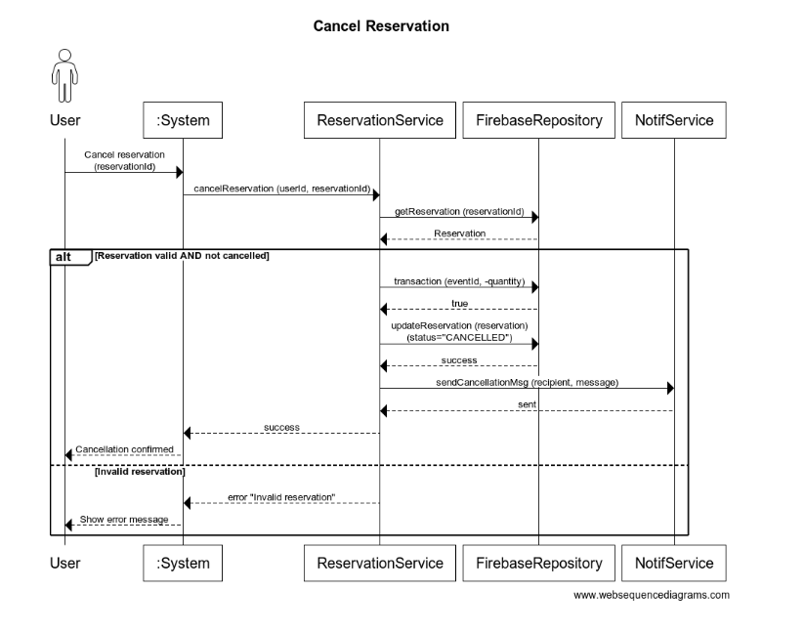

Add New Event - Admin
@startuml
title Add New Event - Admin

actor Admin
participant ":System" as System
participant "EventService" as EventService
participant "FirebaseRepository" as Repo

Admin -> System: Submit event details
System -> EventService: addEvent (adminId, event)

EventService -> Repo: saveEvent (event)
Repo --> EventService: eventId

EventService --> System: eventId
System --> Admin: Event created\n (eventId)

@enduml

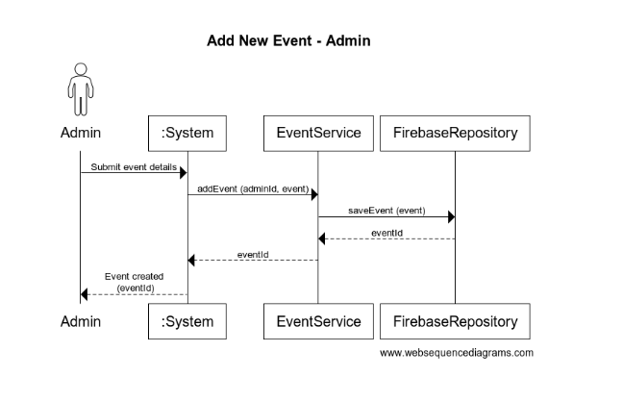

Edit Existing Event - Admin

@startuml
title Edit Existing Event - Admin

actor Admin
participant ":System" as System
participant "EventService" as EventService
participant "FirebaseRepository" as Repo

Admin -> System: Submit updated event\n(eventId, changes)
System -> EventService: editEvent (adminId, event)

EventService -> Repo: saveEvent (event)
Repo --> EventService: success

EventService --> System: success
System --> Admin: Event updated

@enduml

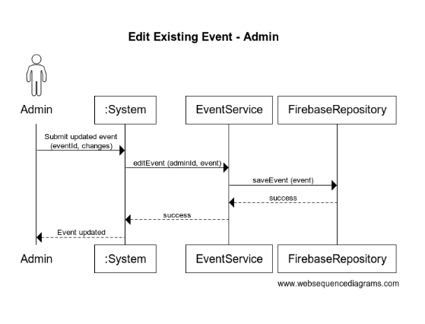

Cancel Event

@startuml
title Cancel an Event - Admin

actor Admin
participant ":System" as System
participant "EventService" as EventService
participant "FirebaseRepository" as Repo
participant "NotifService" as Notif

Admin -> System: Cancel event\n(eventId)
System -> EventService: cancelEvent (adminId, eventId)

EventService -> Repo: getEvent (eventId)
Repo --> EventService: Event

EventService -> Repo: saveEvent (event)\n(eventStatus="CANCELLED")
Repo --> EventService: success

EventService -> Notif: sendCancellationMsg (recipient, message)\n(for affected users)
Notif --> EventService: sent

EventService --> System: success
System --> Admin: Event cancelled\n(users notified)

@enduml

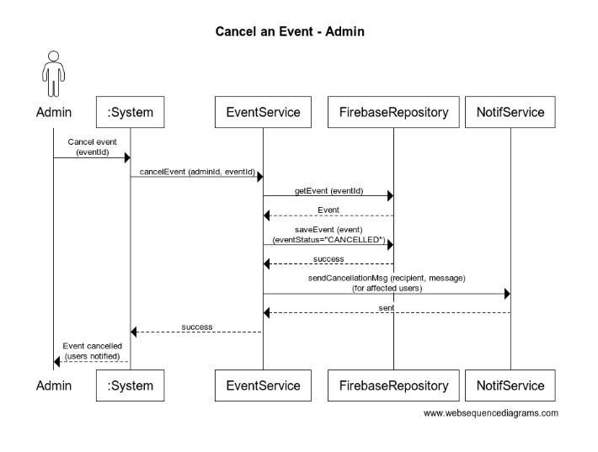

Receive Confirmation

@startuml
title Receive Confirmation (Notification)

actor User
participant ":System" as System
participant "Firebase Realtime DB" as RTDB
participant "ReservationNotifHandler" as Handler
participant "Email/SMS Service" as EmailSMS

System -> RTDB: Create or update reservation/event record
RTDB -> Handler: Trigger notification event\n(reserve/cancel)

Handler -> EmailSMS: send confirmation/cancellation
EmailSMS --> User: Deliver email or SMS

@enduml

